How to get onto Office 365 Teams

In a web browser type ‘office.com’
Click on ‘sign in’
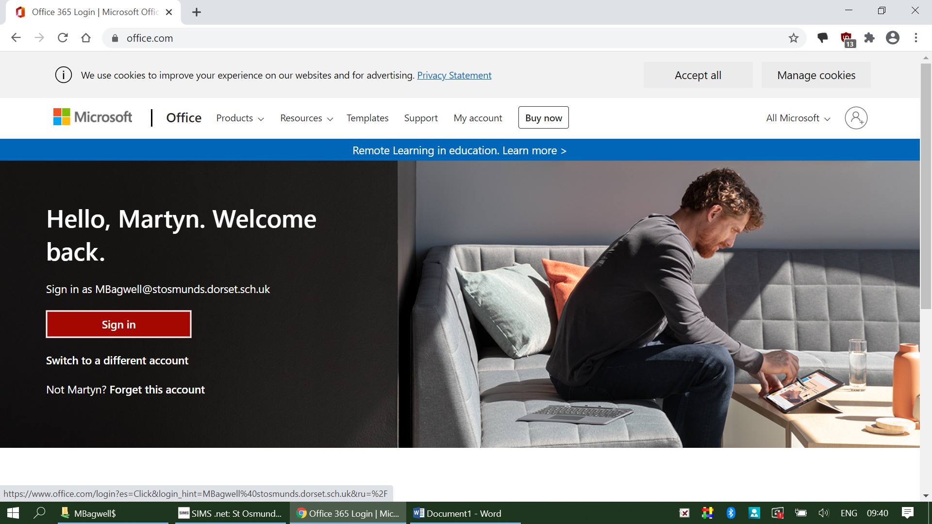

Then type in your email address (firstnamesurname20@stosmunds.dorset.sch.uk) The number after your name will be the year you started St Osmunds ie year 5 20, year 6 19, year 7 18, year 8 17.
Example is John Smith year 5;
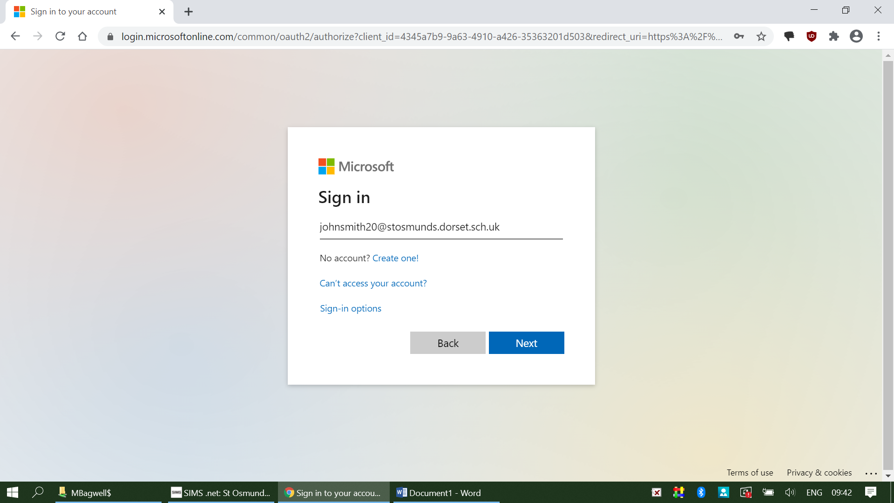

If you have spelt your email wrong it won’t let you past this page.
Next is the password page.
Your Password should be written in your home link book.
It is case sensitive so please make sure CapsLock is NOT on.
You will then get to this screen;
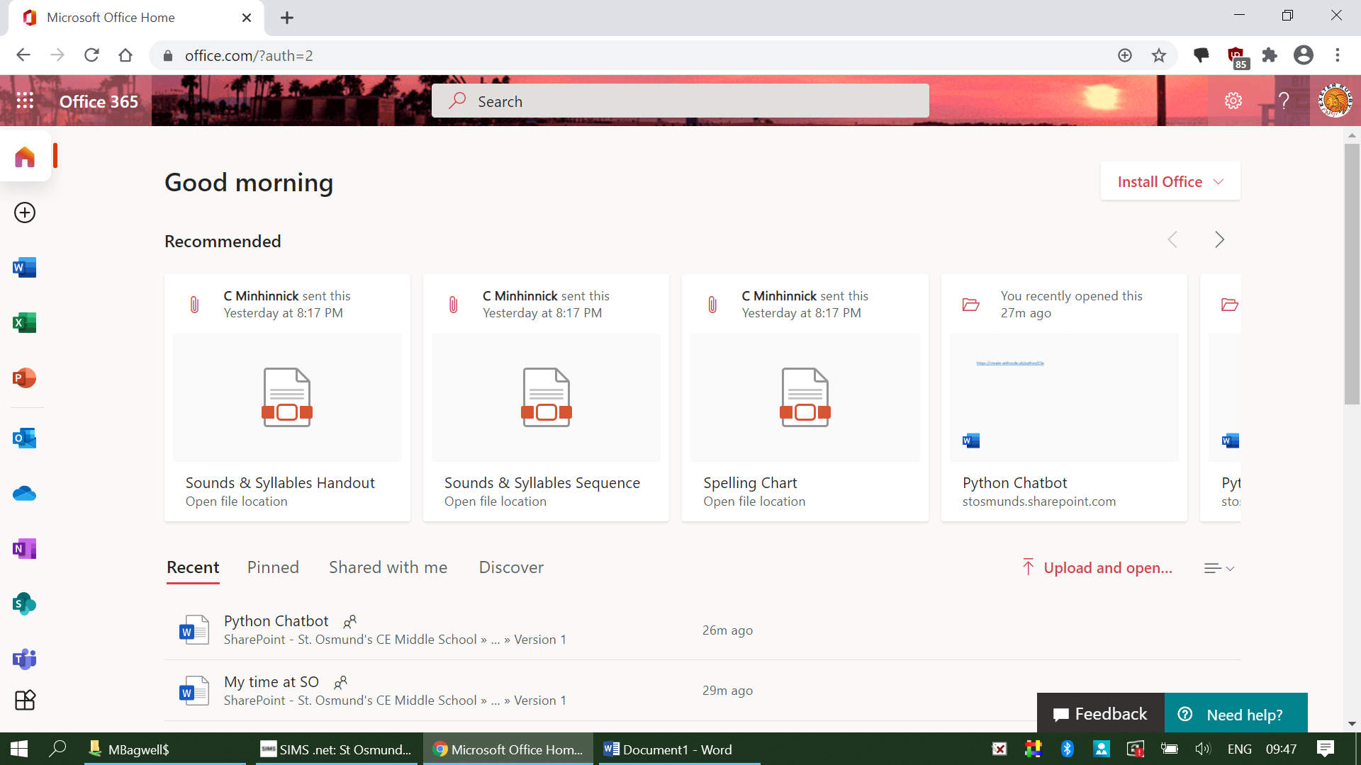

Look at the icons down the left hand side of the screen. You have Microsoft Word, Excel, Powerpoint, Outlook (emails), Onedrive and Teams. These are the ones you will use mostly.
Click on them to open.
When you click on Teams it will bring you to this page;
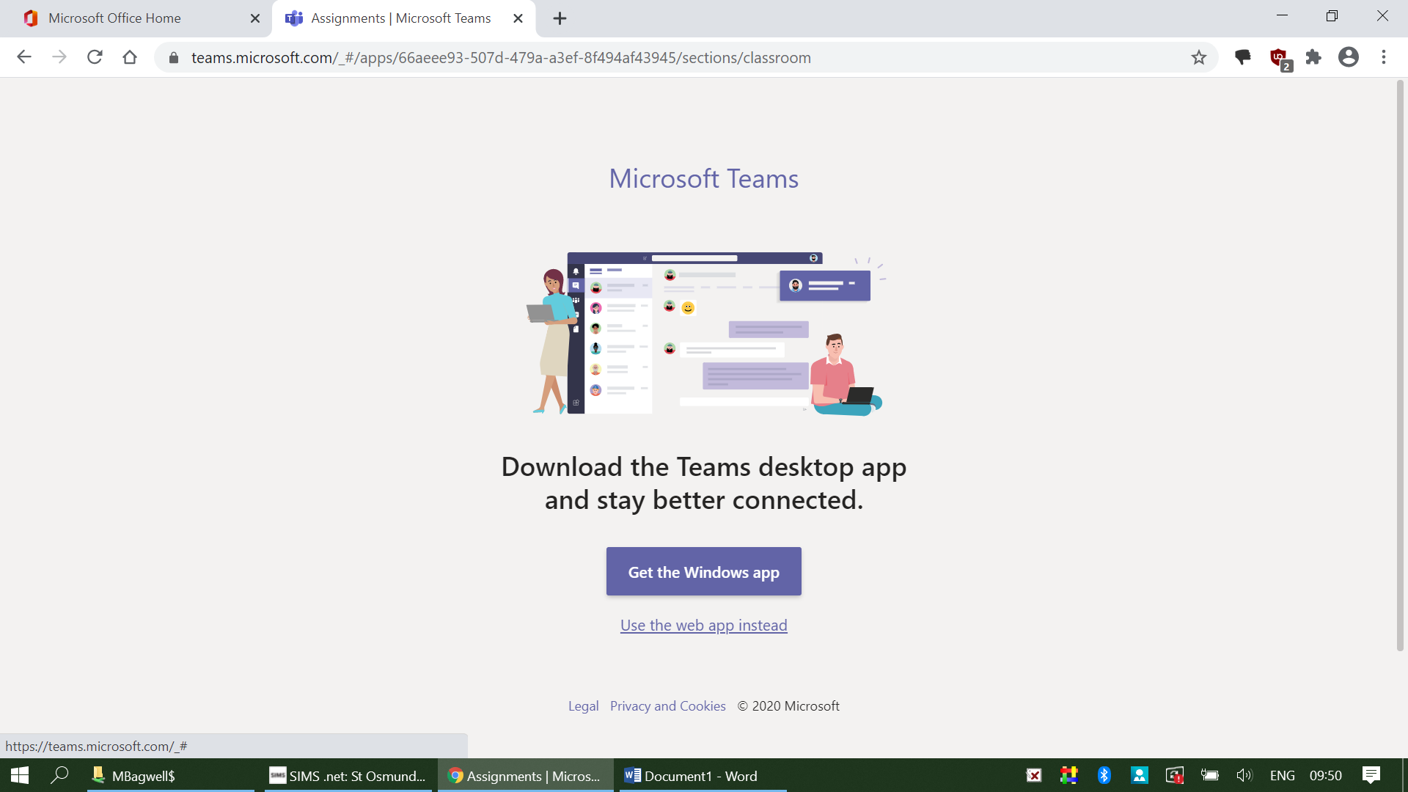
Select the Use the web app instead

